Knowledge engineering report

# Introduction

In this assignment we aimed to combine two different datasets to ultimately produce a set of queries that combine data from both datasets when producing their results. We made use of the geohive; a linked data dataset containing Irish geospatial information such as boundary data per-county, city and even different parishes.

The second dataset we made use of is the “Crimes at Garda Stations Level 2010-2016” dataset, a CSV formatted dataset specifying a list of different Garda-Stations, their Divisions and a set of different crimes that occurred within that station’s jurisdiction over the past year.

<https://data.gov.ie/dataset/crimes-at-garda-stations-level-2010-2016>

# Approach to Ontology Modelling

## Assumptions Made

1. Due to the large amount of data within our dataset, we decided to cut down the statistics across the years, focusing only on 2015 – the most recent year with complete statistics across the whole year.
2. A Division can only be in one county
3. A Division can have many stations
4. A County can have many stations & divisions
5. A County can have multiple different crime counts

## References to sources used/reused

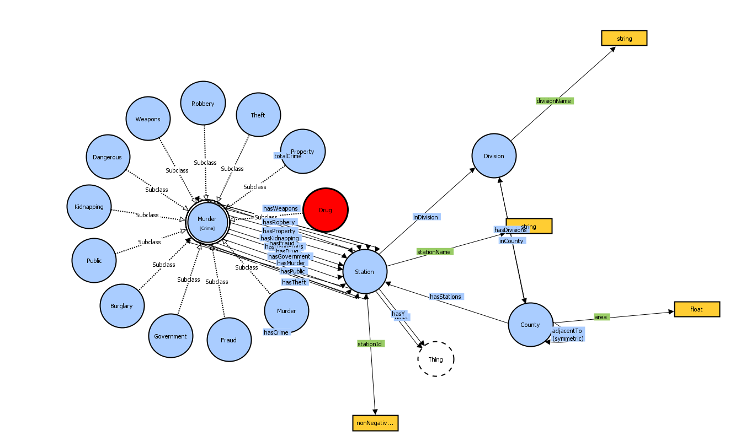

## Data conversion process

# Self-Reflecting Report

## Nicholas Bonello

Most of my focus was on how to create the ontology, modelling the different classes, defining properties per class and evaluating how to interlink the two datasets through different object properties. Once the initial design was decided upon, I began creating the ontology by making use of the Jena toolkit in Java, updating the ontology with suggestions from other team members along the way.

I then used the uplifted crime and Geohive datasets to add all the individuals into the newly formed ontology, ensuring that all object properties are correctly added in for each individual.s